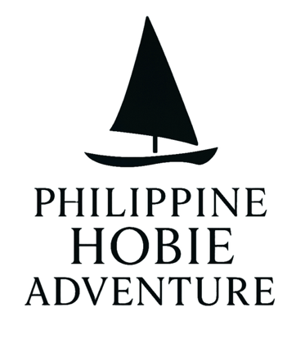

Philippine Hobie Sailing Adventure:

A Solo Journey Through 7,641 Islands

Philippines, Makati City – 02 February 2026 — In what may be one of the most beautiful, exciting, and challenging sea voyages in the Philippines, adventurer and Academy Award-nominated filmmaker Adrian Belic is embarking on the Philippine Hobie Sailing Adventure.

Inspired by the Philippine Hobie Challenge races

(https://en.wikipedia.org/wiki/Philippines_Hobie_Challenge) and Buzzy Budlong, the 1st Filipino to sea kayak the entire 3025km length of the Philippines in 88 days

https://islandbuzzph.com/about-buzzy-budlong/

Adrian’s solo expedition will traverse the length of the Philippine archipelago on a small Hobie 16 catamaran. This sailing journey will cover approximately 2,000 nm (3,700 km 2,300 mi) from the town of Pagudpud on the Northern tip of Luzon island to General Santos City on southern Mindanao island. This voyage is powered solely by wind, embracing a philosophy of harmony with nature and respect for the sea.

The Hobie 16 catamaran—originally designed for day sailing and racing—has never been used for a voyage this long. With only a 7x7 foot (2x2 meter) trampoline deck for living space, Belic will carry everything needed for the journey: navigation equipment, safety gear, camping supplies, tools, spare parts, and provisions. He will come ashore every night to sleep. Adrian anticipates this adventure will take about three months to complete.

More Than Adventure

The Philippine Hobie Sailing Adventure is not simply an athletic challenge — it’s a celebration of Filipino culture, maritime heritage, Mabuhay (Long Live) spirit, and joyful friendliness of the Filipino people. From bustling port towns to remote fishing villages, and secluded natural places few have ever seen, the voyage celebrates the beauty and diversity of the 7,641 islands that make up the archipelago.

The project’s narrative is rooted in exploration and personal connection — sharing local stories with the world, one stop at a time.

About Adrian Belic

Adrian Belic is an Academy Award-nominated documentary filmmaker ("Genghis Blues", 1999), global traveler (140+ countries), entrepreneur, and lifelong sailor. His adventures in the Philippines began during the COVID19 pandemic, when he found himself on Boracay Island, where he started solo stand-up paddleboard journeys to neighboring islands.

Adrian’s voyage will advocate for safety around water and swimming education. With approximately 3,000-4,000 Filipinos drowning annually, Belic aims to promote swimming proficiency and water safety awareness across the archipelago. The project will provide translated resources and connect communities with life-saving information and programs.

"If you don't know about something, it's hard to care about it. If you don't care about it, you won't protect it," Belic explained. "I want to help and encourage more Filipinos to safely experience, explore, learn and love the amazing seas that weave this beautiful archipelago country together.”

Support, Collaboration & Invitation

Acknowledging that no journey of this scale is undertaken alone, the Philippine Hobie Sailing Adventure invites individuals, organizations, sponsors, storytellers, and advocates to participate in supporting and amplifying this adventure and its goals.

Opportunities include logistical collaboration, advocacy partnerships, media engagement.

To follow the journey please visit our page : www.philippinehobiesailingadventure.com

To be connected on social media follow :
Facebook : https://www.facebook.com/philippinehobiesailingadventure/
Instagram : https://www.instagram.com/philippinehobieadventure/
YouTube : https://www.youtube.com/@PhilippineHobieAdventure
TikTok: https://www.tiktok.com/@philippinehobieadventure
X (formerly Twitter) : https://x.com/PhilippineHobie

Our Current Partners :
• Rayo Marine Philippines (boat sponsor)
• Subic Sailing (training and logistics support)
• Blood Red Clothing (sailing gear)
• GoPro Philippines (documentation equipment)

For press inquiries, sponsorship and other collaboration options:
EMAIL : philippinehobieadventure@gmail.com
CONTACT NUMBER : 63 993 3368631

